Program Code
import java.text.SimpleDateFormat;
import java.util.Date;

class Clock {
// Method to continuously update and print the current time
public static void displayTime() {
// Create a thread for continuously updating the time
Thread updateTimeThread = new Thread(() -> {
while (true) {
try {
// Update the time
updateCurrentTime();
// Sleep for 1 second
Thread.sleep(1000);
} catch (InterruptedException e) {
System.err.println("Error in updateTimeThread: " + e.getMessage());
Thread.currentThread().interrupt();
}
}
});

// Create a thread for printing the time to the console
Thread printTimeThread = new Thread(() -> {
while (true) {
try {
// Print the current time
printCurrentTime();
// Sleep for 1 second
Thread.sleep(1000);
} catch (InterruptedException e) {
System.err.println("Error in printTimeThread: " + e.getMessage());
Thread.currentThread().interrupt();
}
}
});

// Set higher priority for the printTimeThread
printTimeThread.setPriority(Thread.MAX_PRIORITY);

// Start the threads
updateTimeThread.start();
printTimeThread.start();
}

// Method to update the current time
private static synchronized void updateCurrentTime() {
// Get the current time
Date now = new Date();
// Display the time in HH:mm:ss dd-MM-yyyy format
SimpleDateFormat sdf = new SimpleDateFormat("HH:mm:ss dd-MM-yyyy");
System.out.println("Current Time: " + sdf.format(now));
}

// Method to print the current time
private static synchronized void printCurrentTime() {
// Get the current time
Date now = new Date();
// Display the time in HH:mm:ss format
SimpleDateFormat sdf = new SimpleDateFormat("HH:mm:ss");
System.out.println("Time: " + sdf.format(now));
}

public static void main(String[] args) {
// Start displaying the time
displayTime();
}
}

Program Screenshot
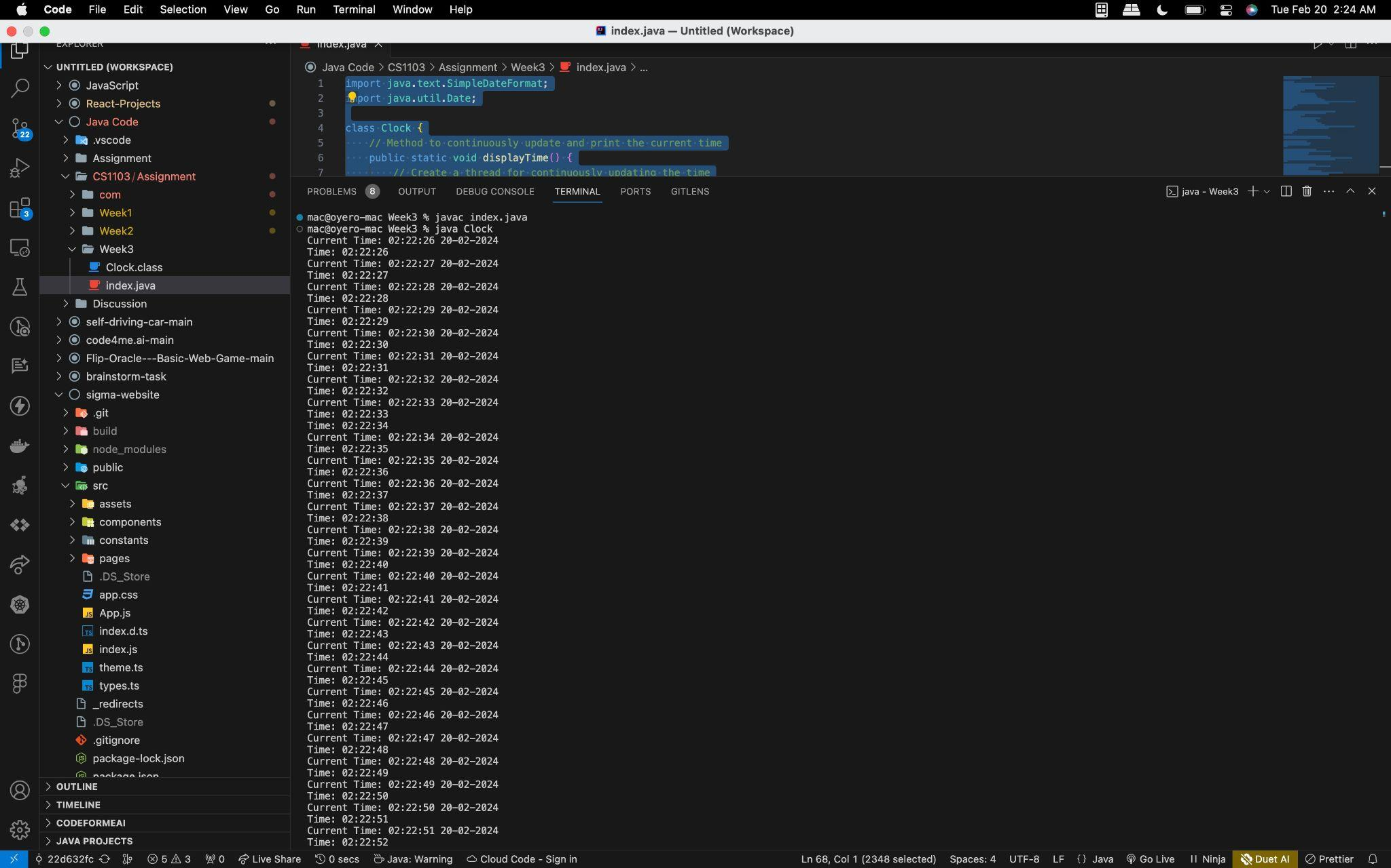

Program Video
Clock-Application.mp4

Program Documentation

Overview
The Clock application is a simple Java program that continuously displays the current time and date. It utilizes Java threads to update the time in the background and print it to the console. Thread priorities are used to ensure better timekeeping precision.

Features
- Displays current time and date in the format "HH:mm:ss dd-MM-yyyy".
- Continuously updates the time in the background.
- Prints the time to the console.
- Utilizes Java threads for concurrency.
- Sets thread priorities for improved timekeeping.

Clock Class
- displayTime(): Method to continuously update and print the current time.
- updateCurrentTime(): Method to update the current time and date.
- printCurrentTime(): Method to print the current time to the console.
- main(): The main method to start the application.

Thread Implementation
- Two separate threads are used: one for updating the time and one for printing it to the console.
- Thread priorities are set to ensure timely console output.

